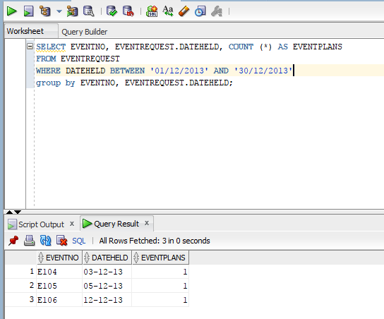
SELECT EVENTNO, EVENTREQUEST.DATEHELD, COUNT (*) AS EVENTPLANS FROM EVENTREQUEST WHERE DATEHELD BETWEEN ‘01/12/2013’ AND ‘30/12/2013’ group by EVENTNO, EVENTREQUEST.DATEHELD;

